Standard cage sizes
Suitable for many types of pets. Cat runs, dog runs , chickens and more
Walk – in heights no having to crawl to clean etc
Comp’s Poultry 0417 933577
OPEN Sat 9 am to 4pm Sunday 10am to 2pm (Corner Stock rd and Campersic rd Herne Hill)
Budget Cage 1.8m long 1.15m wide 1.5m high $ 480 ( garden art work not included )
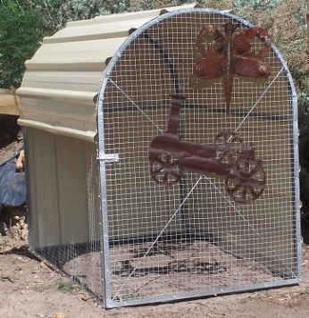Small Cage 1.8m long 1.15 wide 1.6m high two nest boxes and shelf $ 680 ( far right cage of three cages)
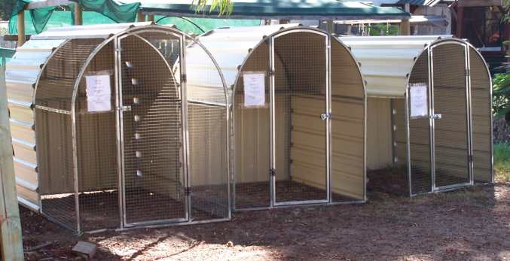
Medium cage 1.8m long 1.4m wide 1.7m high two nest boxes and shelf $ 780 ( middle cage ) Large cage 3.0m long 1.4m wide 1.7m high two nest boxes and shelf $ 950 ( left hand side cage tinned differently)
Please note these are our standard sized cages but we make them here at Comp’s In our own workshop so can make to order to suit your needs. They are fully welded so easily transported and the shape makes them wind tolerant, want blow away like other types. We can also flat pack medium cage if required but without nest boxes and shelf .We also build flat roof cages etc to order.

